 | ISYS358 Group 30  System Requirements Specification  Café Shenkin Mobile Application  Version <1.0>, <29/08/2017>
1. Introduction 3
1.1. Purpose 3
1.2. Scope 3
1.3. Definitions, Acronyms, and Abbreviations 3
1.3.1. Acronyms 3
1.3.2. Abbreviations 4
1.4. References 4
1.5. Overview 4
2. Overall Description 5
2.1. Product Perspective 5
2.2. Product Functions 6
2.3. User Classes and Characteristics 6
2.4. Operating Environment 7
2.5. User Documentation 7
3. Requirements 8
3.1. Functional Requirements 8
3.1.1. Client Side Application 8
3.1.2. Server Side – Café System 9
3.2. Performance Requirements 9
3.3. Design and Implementation Requirements/Constraints 11
3.3.1. Registering Customer 11
3.3.2. Stamping the ‘Digital Loyalty Card’ 11
3.3.3. Notifying Customer about New Deals 12
Description 12
3.3.4. Finding Reward-Track Completion Records 13
3.3.5. Constraints 13
3.3.5.1. Time Constraints …………………………………………... 13
3.3.5.2. Cost Constraints ………………………………………….... 14
3.3.5.3. Scope Constraints …………………………………………..14
3.4. Other Non-Functional Requirements 14
3.4.1. User Interface and Human Factors 14
3.4.2. Documentation 14
3.4.3. Hardware & OS Consideration 14
3.4.4. Security 14
3.4.5. Error Handling & Extreme Conditions 15
3.4.6. Resource & Management Issues 15
3.4.7. Physical Environment 15

Introduction

Purpose
The goal of this project is to provide Café Shenkin with a mobile application solution that integrates with their current IMPOS and MailChimp systems, while updating their loyalty program and marketing strategy to be new and exciting for both existing customers but also new customers.

Scope
- To provide a functional prototype of the application, along with in-depth documentation, resulting in a ‘Proof-of-Concept’ for the Café Shenkin mobile application.
- Create integrated solutions for both customer side and employee side
- To bring the Café Shenkin loyalty program into the digital marketplace via mobile application.
- To improve the reward program for customers.
- Improve marketing potential to customers using application/easier way to gather customer feedback.

Definitions, Acronyms, and Abbreviations

Acronyms
Acronym | Explanation
APP | A Particular Purpose
QR-Code | Quick Reference Code
POS | Point of Sale
HDD | Hard Disk Drive
PAAS | Platform As A Service
PHP | Hypertext Pre-processor
HCI | Human Computer Interaction
XSS | Cross-Site Scripting

Abbreviations
Abbreviation | Definition
IMPOS | Point of Sale system used by Café Shenkin

References
- Requirements Specification for the Fare Selling System for London Underground,07/24/2001, URL: http:www.cuc.ucc.ie/CS3000/notes/LU.html
- The Institute of Electrical and Electronics Engineers, Inc., IEEE Guide to Software Requirements Specifications, IEEE Standard 830-1984, New York, 1984.
- Software Requirements Specification (SRS) what you need to know? by Darren Levy, updated on March 28,2017

Overview
Café Shenkin focuses on delivering a family friendly, inviting, comfortable and quality dining experience to customers. This has led to approximately 80% of customers being regular visitors of the café, and as a result Shenkin has implemented a customer loyalty card to keep those regulars coming back. Café Shenkin would also like to further streamline this process, whilst also gathering data about their customers and improving the customer experience, and has decided to develop a mobile app to address these goals.

Overall Description

Product Perspective
The Digital Café Shenkin Loyalty Reward System consists of two parts: the client-side mobile application and the server-side café loyalty reward system. The mobile application displays a unique QR code which it records customers purchase history and profile, while the server-side café loyalty reward system scans the QR code and provides incentives based on the customer purchase history.

Since this is a data centric system, a database will be used. Both the mobile application and the on-site loyalty reward system will communicate with the database, but in a different way.

The mobile application will mainly receive data (read only connection) from the database to obtain and update customer’s detail after they have registered their profile on the application. System information such as real-time push notifications or advertisements from the café system can also be received with the mobile application.

The server-side loyalty reward system requires an external QR scanner to identify individual customer profile and administrative access to the database to add and modify data. Both the mobile application and the on-site system’s database communication will go over the internet.

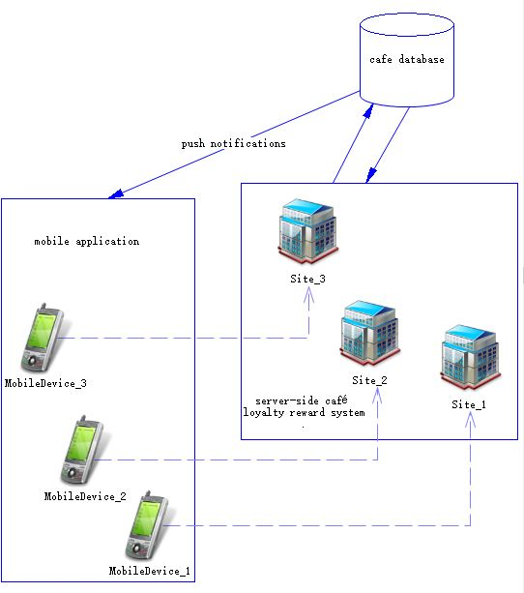

Product Functions
The following list outlines and describes the main features and functionalities of the Digital Café Shenkin Loyalty Reward System. The features are split into two major categories: core features and optional features. Core features are the core function of the system, whereas optional features provide new functionalities to the reward system and it can be implemented as time permits.

Core Features:

- Registering customers
- Allow user to register into the café database
- Create a unique QR code in the mobile application

- Stamping the “Digital Loyalty Card”
- Record purchase history into the café database
- Receive incentives if under correct condition

- Push notifications
- Display notification messages on customer’s mobile device about the promotions
- Able to add, edit and remove promotions on the server-side system

- Reward completion tracking
- Record and display customer’s purchase history
- Display information and completion status about the reward

Optional Features:

- Market analysis
- By analysing the transaction data stored in the database, Café Shenkin can utilise the information to discover new revenue opportunities and predict market trends

- Locate nearest store
- Utilise Google Maps to display stores nearby

- Potential online payment integration and pre-order function
- Implement a secure, online transaction on mobile device
- Incorporates the mechanism to achieve remote food order

- Potential Mobile e-commerce
- Online store for Café Shenkin merchandise products

User Classes and Characteristics
There are three classes of user that interact with the system: user of the mobile application, the server-side operator and the system administrator. Each of these three types of user has different use of the system.

The mobile application user only uses the application to identify themselves as a member of the system (customer) by showing their unique QR code. This can be achieved by simply open the application on their mobile device. Therefore, this user class requires no technical experience to operate the system.

The server-side operator acts as a customer service in store and offer incentive based on the customer profile. Customer profile can be obtained by using the QR scanner connected to the point of sale (POS) system instore. This user type requires the technical know-how of the POS system and the external QR scanning device.

The administrator interacts with the server-side café loyalty reward system only. They will manage the overall system so there is no incorrect information within. The administrator has the right to add, edit and remove all the reward and promotion within the Digital Café Shenkin Loyalty Reward System.

Operating Environment
The main component of the Digital Café Shenkin Loyalty Reward System is the mobile application, which will be available on both iOS and Android operating systems. The application is not resource intensive so there are no hardware constraints, but does require internet connection in order to receive push notification. The other component is the server-side system, an application that cooperates with the POS system. A QR scanning device and internet connection between the POS and the café database is required.

Both the mobile application and the server-side system require internet connection to the cafe database. Which operates on Windows platform and installed with MySQL database and Apache webserver.

User Documentation
The primary goal of Digital Café Shenkin Loyalty Reward System is to provide simple point-reward experience. Consequently, the system will be designed to be as simple to use as possible. The application will be intuitive and self-explanatory, and a common FAQs page will be available on the mobile application.

Requirements

Functional Requirements

Client Side Application
Requirement Number | Requirement
R01 | The product shall allow customers to register with the ‘Café Shenkin (database)’.
R02 | The product must allow editing customer details.
R03 | The product shall issue ‘customer registration number’ for future reference.
R04 | The product must realise valid email addresses and phone numbers during registration process.
R05 | The product must have ‘Search’ facility to identify valid customer by their name, email ID or phone number.
R06 | The product shall use links for other marketing campaigners.
R07 | The product must have built in ‘QR code’ reader to interact with the client application.
R08 | The product must display acquired reward in a ‘Rewards’ section.
R09 | The product must have way to track ‘Rewards’.
R10 | The product must receive reward notification or advertisement from the café system.
R11 | The product shall have ability to book table(s) at the restaurant (optional).
R12 | The product shall have ability to update/delete booking (optional).

Server Side – Café System
Requirement Number | Requirement
R13 | The product must allow updates/deletion of customer details.
R14 | The product must identify valid customers in the ‘Loyalty Program’.
R15 | The product must allow create/update/delete reward program as per required.
R16 | The product must notify customers about current deal(s).
R17 | The product shall have ability to locate customers who have completed their reward tracks any number of times as well as print their contact details.
R18 | The product shall have ability to further reward customers based on their previous reward completion records (optional).
R19 | The product shall edit/delete bookings (optional).
R20 | The product shall print booking lists (optional).

Performance Requirements
Requirement Number | Requirement
R21 | The product shall issue a ‘customer registration number’ within 1 second of receiving correct customer details into the database.
R22 | The product shall load interfaces with information within 2-3 seconds of receiving commands.
R23 | The product (café system) shall load search result within 2 seconds of receiving filtering criteria.
R24 | The product (client app & café system) shall update records with one another within 2-3 seconds of receiving information.
R25 | The product shall send out notification/deal/advertisement as a batch process within 5 seconds of its generation from the café system.
R26 | The product (café system) shall support 15,000 records in its database.
R27 | Initially the product will be designed for the Android system, with development growing onto the Apple platform.
R28 | The product shall able to respond efficiently during peak business hours.
R29 | The entire system (client app & café system) shall able to process min. 300 transactions at any given point without any hiccups.
R30 | 95% of its response time (entire system) shall be less than 3 sec.
R31 | During rush hours, the product must estimate approximate wait time for the customers to gain access to the system at the time of ‘Loading...’ or ‘Processing in ___ sec.’.
R32 | The UI of the product shall be user friendly in a way that it will be easy to operate in a busy café environment using one hand only.
R33 | The product (café system) shall load the client record on display within 1 sec of using QR-code from the client app.

Design and Implementation Requirements/Constraints

Registering Customer
Description:
The system shall register customers into café database

Input:
Refer to requirement R01.

Operation:
Step 1: Open the app
Step 2: Create profile/customer details
Step 3: Click ‘Save’ to save the profile to the database (café server)
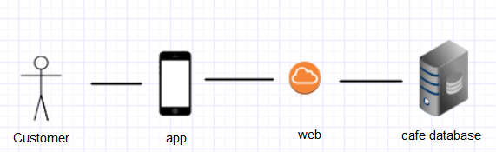
Internal process
- Stores customer profiles over the internet in to Café Shenkin’s database
- View/update customer profile in the app

Stamping the ‘Digital Loyalty Card’
Description
During purchase at POS (point of sale), café system shall auto lookup customer record on ‘Display screen’ by using QR-code (as input) from the client app. Upon digital stamping by the staff at POS, the café system shall auto update the reward track in both client and server machine.

Input
Refer to requirements R07 and R14.

Operation
Step 1: Make the order
Step 2: Open the app
Step 3: Go to ‘Loyalty Card Digital’
Step 4: Scan the QR-code of the app with the café system
Step 5: Stamp the purchase electronically (In the café system)
Step 6: Auto Update both client and server over the internet

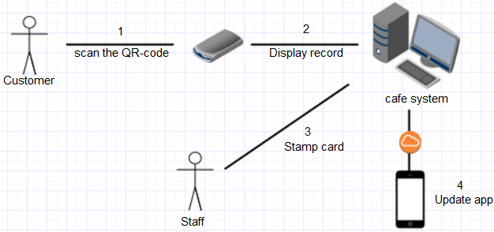
Internal process
- Digitally mark the Loyalty card
- Auto update reward tracker (both customer app and café system)
- Displays available rewards on the spot

Notifying Customer about New Deals

Description
The product (café system) shall notify customers about new deals upon creation on the server side café machine.

Input
Refer to requirements R10, R16 and R18.

Operation
Step 1: Open the café system
Step 2: Go to ‘Create New Deal’
Step 3: Enter deal
Step 4: Save the deal
Step 5: Click ‘Send Deal for Marketing’
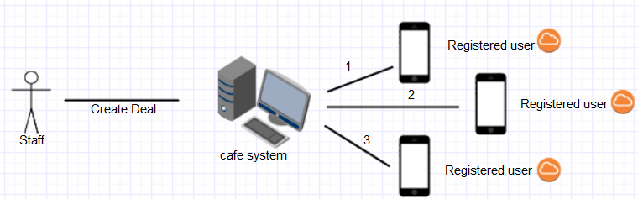

Internal process
- Newly created deal will be saved to the café system.
- A copy of the deal will be posted (over the internet) to all the recipients who are registered with the app.

Finding Reward-Track Completion Records
Description
The system shall have the ability to locate customers who have successfully completed the reward track one or many times.

Input
Refer to requirements R9, R17 and R18

Operation
Step 1: Open the café system
Step 2: Go to ‘Track Reward’
Step 3: Click ‘Find customers’ who have completed the reward-track

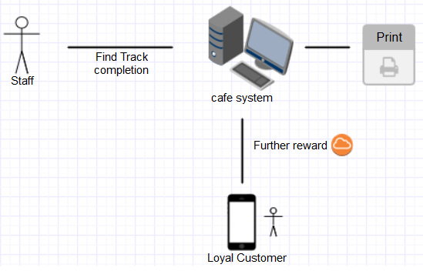
Internal process
- Generates a list of customers who have completed a reward track for any given marketing campaign
- Café system can forward any further reward/discount to their loyal customers, if they wish to.

Constraints

Time Constraints
We need a prototype to be readily available with common functionalities for our client by 13/10/2017.

Cost Constraints
The product that we are planning to develop can be built using freeware development products like Apache, MySQL and PHP. Where PHP as server-side scripting language on Apache webserver using MySQL as its backend database. However, running a complete product or beta on fee charging application server in PAAS environment can be expensive as database gets bigger (let’s say we are dealing over 15,000 records i.e. more than our initial estimate). Therefore, additional charges can be incurred for the business for this kind of services. However, product deployment in PAAS environment is optional, if business can archive old records and keep the records below 15000. But good news is PAAS can also controls heavy traffic during pick-hours with no extra cost for ‘Internet Security’ that ensures hacking out of the system, which are added advantages for the business.

Scope Constraints
The app is limited to being a prototype only with basic functionalities of client and server as mentioned earlier in the time constraints. When the actual product is developed and finalised then it will enter in to maintenance cycle.

Other Non-Functional Requirements

User Interface and Human Factors
The user interfaces of the product must be user friendly and easy to operate in a busy cafe environment with using one hand only by following HCI principals.

Documentation
The product shall maintain its design & development documentation throughout its life cycle.

Hardware & OS Consideration
- Intel core i7 processor, 256 Mb RAM with 700 GB HDD in Windows 8 or above will be ideal for the system.

- MySQL database shall be stored in Windows environment (8 or above) using Apache webserver to interact with the database.

- A local area network (LAN) between Café database (server) and IMPOS/POS (point of sale) shall be required.

Security
The product shall implement ‘output encoding’ (i.e. converting untrusted input into safe form where input will only be displayed as data without executing as code in the browser) to prevent the back door of hosting malware in the system by using cross-site scripting or SQL injection.

Error Handling & Extreme Conditions
The system must implement validation criteria for data entry errors. If possible guide users to take action in case of extreme error conditions. If not send a detail error report to the system log file to analyse and solve by the experts in later date.

Resource & Management Issues
The café system (server-side) shall take auto backup in every 12 hours. A team member from the development, will be responsible for the required system maintenance.

Physical Environment
The server machine, where the café database will be hosted using MySQL interacting with Apache webserver shall be kept out of reach (café staffs). Only maintenance people shall have direct access to the café system server.

